19.53: a) The fractional change in volume is

b)

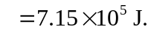d) 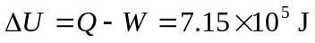to three figures. e) Under these conditions, there is no substantial difference between 